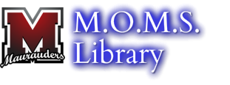
3R’s Activity Schedule

The following activity schedule represents the various programs that have gathered in the library, which has aimed to serve curriculum-related areas that influence student interests and career goals in a variety of different fields. The music group has hosted numerous concerts, Anime has led book clubs and art learning programs, newspaper has written an article for submission to the NJ Council of English Teachers’ statewide newsletter, graphics has taught Photoshop and explored InDesign, while Film and Broadcasting groups has created broadcasted Advisory videos.
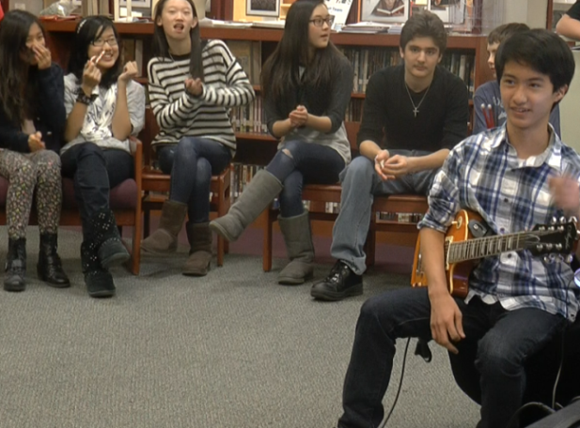
The Music Group (7&8):
Students interested in performing, composing, singing, instrumentation, and dancing come together in the library during 3R’s to rehearse, make friends, and plan performances. When ready, tickets are printed inviting the greater student body to watch and appreciate their talents. (7th & 8th Grade)

Anime & Manga (6&7):
Students who love Anime and graphic novels teach each other Japanese Manga drawing techniques, watch and discuss anime, talk about their favorite characters and plotlines, and learn games and competitions for anime. (6th & 7th Grade)

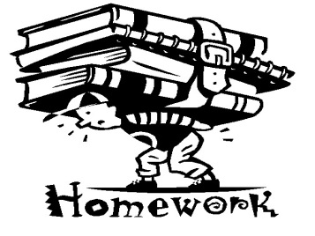
Peer Tutoring (ALL):
Students who come for M.O.M.S. Library Peer tutoring will receive help in academic subjects and coursework that they may need assistance. Students who have been trained to help their peers will be available for assistance. (All Grades)

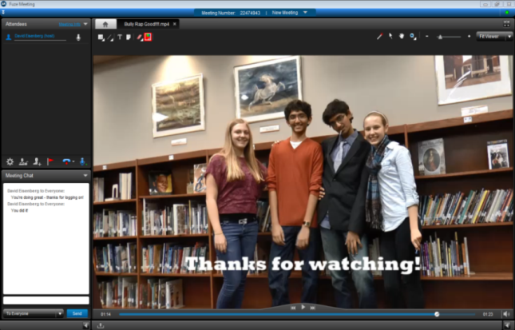
Film & Broadcasting (7&8):
Act, direct, produce, perform and create independent movies, informational videos, and advisory broadcasts. When finished, videos may be broadcast throughout the school during advisory, entered into film contests, or shown to students at special library screenings during 3R’s. (8th Grade)

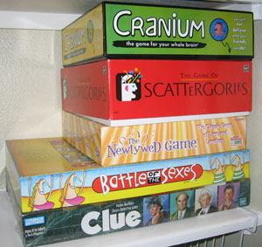
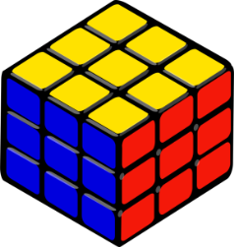
Games (ALL):
Play board games in the library with friends. Contests, competitions, and more! Bring in your favorites or play the ones we have in here. Or take part in the “solve the rubix cube club” (6th & 8th Graders)
Newspaper Crew (7):
Students in the new M.O.M.S. Student Newspaper design websites, write articles, film short documentary interviews, cover sports events, and report on everything that’s important and exciting to students at M.O.M.S. (7th Grade)

Graphics
Engage in the art and science of special effects, Photoshop, digital animation, the Kinect for Windows, and other software that makes Hollywood movies and advertising magic. (6th Grade)

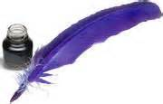
Creative Writing & Film (6&7):
Students learn about the art of writing novels, short st0ries, and learn about competitions and contests, as well as how to get published for the work you’ve written. (6th & 7th Grade)
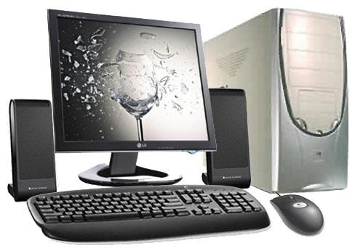
Library Student Team (6&7):
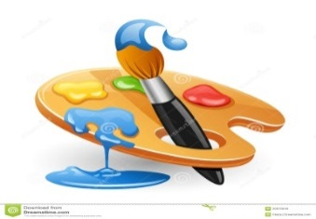
Help out in the library by adopting a shelf, checking out books, shelving, helping plan which new novels we’ll order, troubleshooting technology, planning new library events, and other projects as they come up. (6th & 7th Grade)

Fine Arts (8):
Learn about creating and conceiving art in the library. Draw, paint, or practice any form of artwork that can be done in the library among friends. (8th Grade)

